FLEETWOOD MODEL YACHT CLUB
F/S (Vane) 36” class Nationals 24&25 May
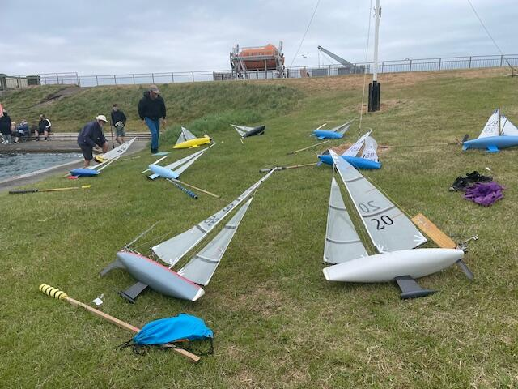
Fleetwood MYC hosted the F/S 36” class championship over the May bank holiday sat & sun, and welcomed 21 boats to a very windy weekend.
The club’s only other hosting of this event was back in the 1970’s, so it was time for a return for the class.
For those who don’t know, Vane racing is a series of match races run on a tournament system, where each boat races each other both ways of the lake scoring 3 points for a win upwind & 2 points for a win downwind. The boat with the most points, at the end, is the winner.
The first running of this MYA Championship was at Birkenhead in 1933, and was won by Fleetwood member Albert Wright (coxswain of the Fleetwood lifeboat at the time). Last year’s championship was also at Birkenhead and was also won by a Fleetwood member Peter Whiteside!
The 36” class is quite literally a “box” rule. Boats must fit in a box 36”x 9”x !!” and must weigh no more than 12lbs. Sail area shape & size is completely unrestricted. (although this wasn’t a problem this weekend!)
The event was hotly contested with 3 World & countless National Champions taking part, you’d have thought you were at an IOM Ranking weekend! Some of the boats are family heirlooms having been handed down through the family!
This event always attracts families and it was great to see several mums Dads ^ kids taking part all joining in the fun. And what fun we had with 20+ knots of westerly breeze straight down Fleetwood’s 270 yard long lake producing some very large waves at the leeward end sometimes making it difficult for the small boats to get through them. The runs were spectacular with the bravest flying their spinnakers! Several people remarked that they did not think it was possible to make such small boats go so fast!!
Right from the start Chris Harris stamped his authority on the event on the event by losing only one race upwind and none downwind all day Saturday. Also showing well in the scores was Oliver Stollery having lost no beats, (upwind) and just 3 runs (downwind).

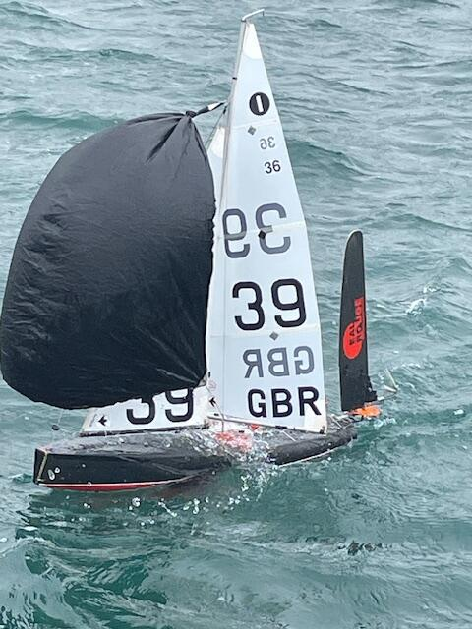
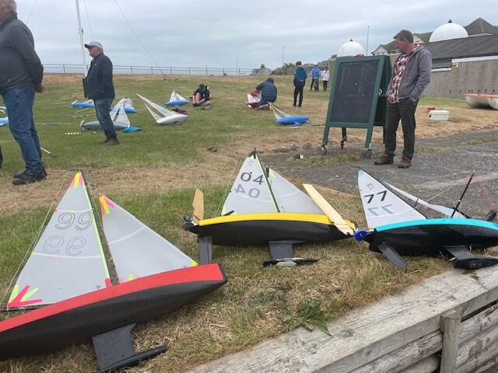
Sunday dawned and found even more wind 30+ knots. Martin Roberts’ measure of a good heavy weather boat is “can you get up Fleetwood lake in 3rd suit?” We were about to find out. Peter Iles had been at the club since 7am making a small rig from some old R/C Laser sails! Various other people were trying to find small enough sails for the conditions. 2 couldn’t and withdrew for the rest of the event. Lewis Wyeth showed everyone it was possible to manage the conditions by sailing up the lake against the wind & waves then setting his spinnaker and returning down the lake in a ball of spray! There by demonstrating that racing was possible!
So off we went again with sails flattened, sheets eased and did our best with the conditions. The bravest still flew their spinnakers and ran like hell after their boats! All the sailors helped each other to ensure that there were no damaged boats, or people!
At 3pm on Sunday we called a halt, worked out the scoring percentages, and presented the prizes to a tired but happy bunch of sailors.
As expected Chris Harris won with 88%. Martin Dovey 2nd with 80% and Shaun Wyeth 3rd with 76%
Pugwash Trophy (highest club team) Chris Harris & Martin Dovey.
Team Of Two random drawn Oliver Stollery & Derek Priestley.
The sailors all agreed it had been a great experience to race these small boats in such extreme conditions, and went home tired but happy.
Hopefully the class will return sooner next time!

Derek Priestley.

